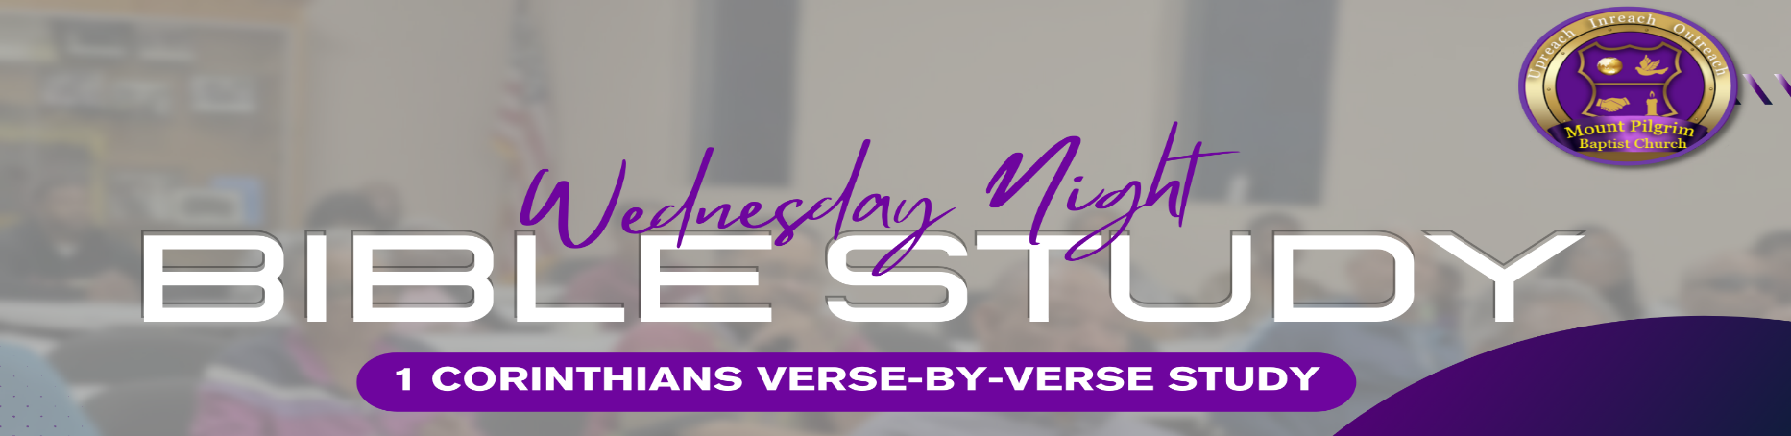
1 Corinthians 3:8-23

8 Now he who plants and he who waters are one, and each one will receive his own reward according to his own labor. 9 For we are God’s fellow workers; you are God’s field, you are God’s building. 10 According to the grace of God which was given to me, as a wise master builder I have laid the foundation, and another builds on it. But let each one take heed how he builds on it. 11 For no other foundation can anyone lay than that which is laid, which is Jesus Christ. 12 Now if anyone builds on this foundation with gold, silver, precious stones, wood, hay, straw, 13 each one’s work will become clear; for the Day will declare it, because it will be revealed by fire; and the fire will test each one’s work, of what sort it is. 14 If anyone’s work which he has built on it endures, he will receive a reward. 15 If anyone’s work is burned, he will suffer loss; but he himself will be saved, yet so as through fire. 16 Do you not know that you are the temple of God and that the Spirit of God dwells in you? 17 If anyone defiles the temple of God, God will destroy him. For the temple of God is holy, which temple you are.
- UNITY IN SERVICE (Verses 8-9):
Both planting and watering are necessary for growth. We are all co-workers in God's service, each with unique contributions but working toward the same purpose.
- Reflection Questions
    - How does the concept of "co-workers in God’s service" challenge us?
    - What are some practical steps we can take to promote unity and collaboration among believers with different gifts and roles in serving God's kingdom?
_____________________________________________________________________________________________________________________ _____________________________________________________________________________________________________________________ _____________________________________________________________________________________________________________________

- THE RIGHT FOUNDATION (Verses 10-11):
Paul emphasizes the importance of building on the foundation of Jesus Christ. Our faith and actions must align with the teachings of Christ and His gospel. Anything built on a different foundation will not last.
- Reflection Questions
    - Reflecting on your life, what are the foundational principles or beliefs that guide your decisions and actions?
_____________________________________________________________________________________________________________________ _____________________________________________________________________________________________________________________ _____________________________________________________________________________________________________________________

- QUALITY OF WORK (Verses 12-15):
Different materials represent the quality of our actions and contributions to the Kingdom. Gold, silver, and costly stones symbolize durable and valuable work, while wood, hay, and straw represent lesser quality. We will be held accountable for how we serve and build in God's kingdom. Our rewards or losses will reflect the quality of our contributions.
- Reflection Questions
    - How can we discern what materials our contributions are built with?
    - How can we cultivate a heart that prioritizes quality and faithfulness in our service?
_____________________________________________________________________________________________________________________ _____________________________________________________________________________________________________________________ _____________________________________________________________________________________________________________________

