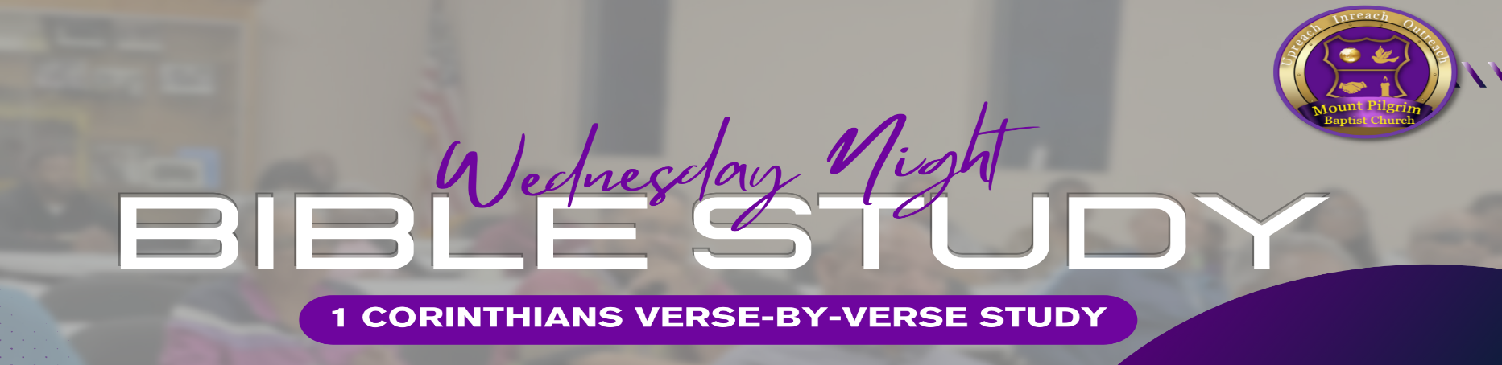

1 Paul, called to be an apostle of Jesus Christ through the will of God, and Sosthenes our brother, 2 To the church of God which is at Corinth, to those who are sanctified in Christ Jesus, called to be saints, with all who in every place call on the name of Jesus Christ our Lord, both theirs and ours: 3 Grace to you and peace from God our Father and the Lord Jesus Christ. 4 I thank my God always concerning you for the grace of God which was given to you by Christ Jesus, 5 that you were enriched in everything by Him in all [b]utterance and all knowledge, 6 even as the testimony of Christ was confirmed [c]in you, 7 so that you come short in no gift, eagerly waiting for the revelation of our Lord Jesus Christ, 8 who will also confirm you to the end, that you may be blameless in the day of our Lord Jesus Christ. 9 God is faithful, by whom you were called into the fellowship of His Son, Jesus Christ our Lord.
- Lesson of Calling (1 Corinthians 1:1-2):
  - "Paul, called to be an apostle of Christ Jesus by the will of God..."
  - “to the church of God… called saints…”
  - Lesson: Recognize and embrace your calling. Understand that your purpose in life is often tied to God's will for you. Seek to understand your calling and fulfill it with dedication and faith.
_____________________________________________________________________________________________________________________ _____________________________________________________________________________________________________________________ _____________________________________________________________________________________________________________________

- Lesson of Grace and Peace (1 Corinthians 1:3):
  - "Grace and peace to you from God our Father and the Lord Jesus Christ."
  - Lesson: Paul always give this salutation. Therefore, the impact of its significance can be missed. Grace is always before peace. And so too for spiritual life.
_____________________________________________________________________________________________________________________ _____________________________________________________________________________________________________________________ _____________________________________________________________________________________________________________________

- Lesson of Thanksgiving (1 Corinthians 1:4):
  - "I always thank my God for you because of his grace given you in Christ Jesus."
  - Lesson: Cultivate a spirit of gratitude. Regularly express thanksgiving for the people in your life and the blessings you have received. Acknowledge that everything is ultimately a result of God's grace.
_____________________________________________________________________________________________________________________ _____________________________________________________________________________________________________________________ _____________________________________________________________________________________________________________________

- Lesson of Spiritual Enrichment (1 Corinthians 1:5-7):
  - "For in him you have been enriched in every way—with all kinds of speech and with all knowledge—God thus confirming our testimony about Christ among you."
  - The Corinthian church came short in no spiritual gift.
  - Lesson: Recognize that your spiritual journey is a continuous process of enrichment. Seek growth in knowledge, wisdom, and spiritual gifts. Share your testimony about Christ to inspire and uplift others.
_____________________________________________________________________________________________________________________ _____________________________________________________________________________________________________________________ _____________________________________________________________________________________________________________________

- Lesson of God's Faithfulness (1 Corinthians 1:8-9):
- "He will also keep you firm to the end, so that you will be blameless on the day of our Lord Jesus Christ. God is faithful, who has called you into fellowship with his Son, Jesus Christ our Lord."
- Lesson: Trust in God's faithfulness. Know that God will sustain you, and His promises are reliable. Embrace the assurance that He will keep you steadfast until the end.
_____________________________________________________________________________________________________________________ _____________________________________________________________________________________________________________________ _____________________________________________________________________________________________________________________

