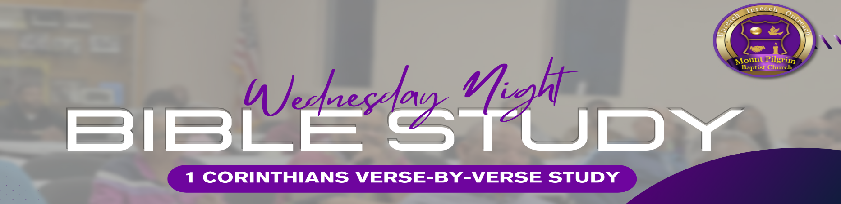
1 Corinthians 3:12-23

12 Now if anyone builds on this foundation with gold, silver, precious stones, wood, hay, straw, 13 each one’s work will become clear; for the Day will declare it, because it will be revealed by fire; and the fire will test each one’s work, of what sort it is. 14 If anyone’s work which he has built on it endures, he will receive a reward. 15 If anyone’s work is burned, he will suffer loss; but he himself will be saved, yet so as through fire. 16 Do you not know that you are the temple of God and that the Spirit of God dwells in you? 17 If anyone defiles the temple of God, God will destroy him. For the temple of God is holy, which temple you are. 18 Let no one deceive himself. If anyone among you seems to be wise in this age, let him become a fool that he may become wise. 19 For the wisdom of this world is foolishness with God. For it is written, “He catches the wise in their own craftiness”; 20 and again, “The Lord knows the thoughts of the wise, that they are futile.” 21 Therefore let no one boast in men. For all things are yours: 22 whether Paul or Apollos or Cephas, or the world or life or death, or things present or things to come—all are yours. 23 And you are Christ’s, and Christ is God’s.
- QUALITY OF WORK (Verses 12-15):
Different materials represent the quality of our actions and contributions to the Kingdom. Gold, silver, and costly stones symbolize durable and valuable work, while wood, hay, and straw represent lesser quality. We will be held accountable for how we serve and build in God's kingdom. Our rewards or losses will reflect the quality of our contributions.
- Reflection Questions
    - How can we discern what materials our contributions are built with?
    - How can we cultivate a heart that prioritizes quality and faithfulness in our service?
_____________________________________________________________________________________________________________________ _____________________________________________________________________________________________________________________ _____________________________________________________________________________________________________________________

- YOUR BODY IS A TEMPLE (Verses 16-18):
These verses emphasizes the sacredness and importance of your body. It encourages you to treat yourself and others with respect, dignity, and care, recognizing that our bodies are not just physical vessels but also spiritual dwellings for God's presence.
- Reflection Questions
    - How do I honor and care for my body as a sacred dwelling of God's Spirit?
_____________________________________________________________________________________________________________________ _____________________________________________________________________________________________________________________ _____________________________________________________________________________________________________________________

- WORLD’S WISDOM VS GOD’S WISDOM (Verses 19-23):
This highlights the importance of seeking God's wisdom and guidance in our lives. It reminds us that God's wisdom often contradicts what the world considers wise, and we should align our thoughts and actions with His wisdom above all else.
- Reflection Questions
    - What areas of my life might be influenced more by worldly wisdom than by God's wisdom, and how can I align them better with His truth?
_____________________________________________________________________________________________________________________ _____________________________________________________________________________________________________________________ _____________________________________________________________________________________________________________________

